**Smart Expense Tracker**

**Phase 5: Apex Programming (Developer)**

Apex provides the backend logic for handling expense operations:

* **Apex Classes:**
  + ExpenseController.cls manages business logic for saving, retrieving, and updating expense data.
* **Apex Triggers:**
  + **Before Insert** → Prevent duplicate receipt uploads.
* **Batch Apex:** Process large sets of expense records.
* **Queueable Apex:** Handle asynchronous tasks.
* **Test Classes:** Written to ensure code reliability and >75% coverage.

**Apex Classes**

**1. ExpenseController.cls**

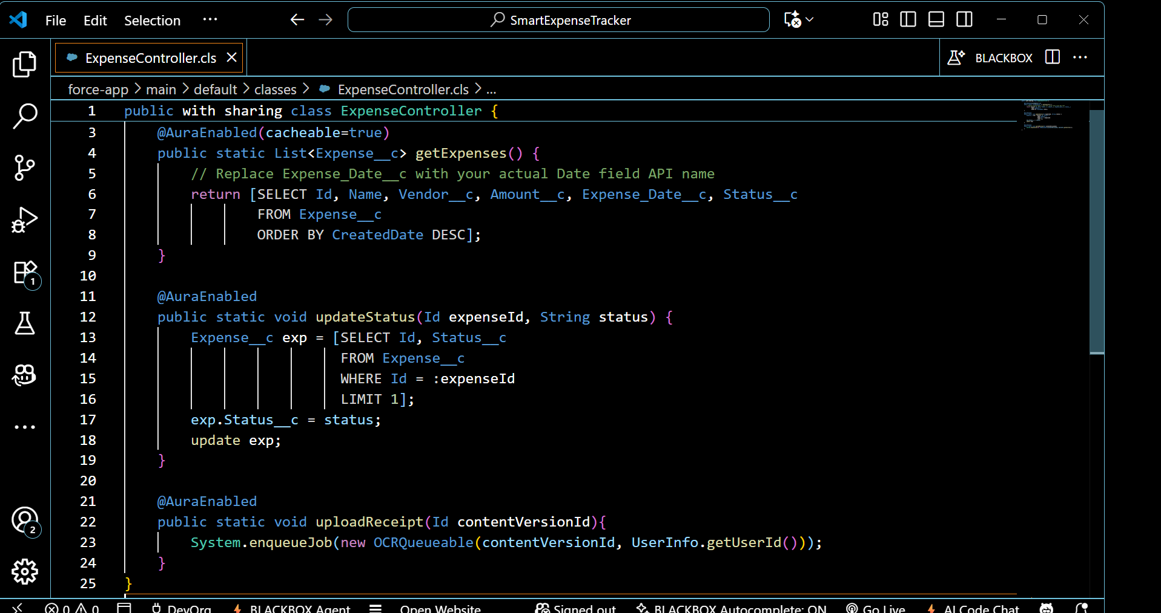

**2.** **OCRQueueable.cls**

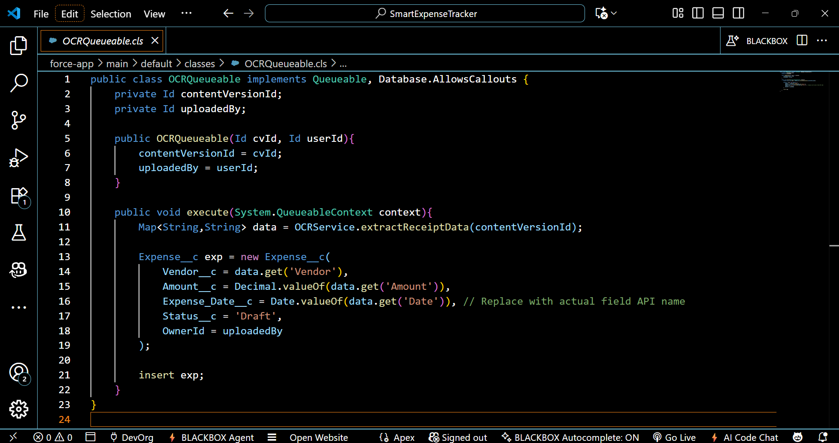

**3.** **OCRService.cls**

